**LAB 12**

**Lab Task. 12.1) Write a program to generate a number table of the given value. The user should be asked for RE-RUN or EXIT the program giving up the following massage; “Do You Want To Continue (Y/N)”.**

#include <iostream>

using namespace std;

int main() {

char ans = 'N';

do {

//Calculator start

int n, range;

cout << "Enter the number of the required table: ";

cin >> n;

cout << "Enter range of table: ";

cin >> range;

for (int i = 1; i <= range; ++i) {

cout << n << " * " << i << " = " << n * i << endl;

}

//Calculator end

cout << "Do you want to continue (Y/N)?\n";

cout << "You must type a 'Y' or an 'N' :";

cin >> ans;

} while ((ans == 'Y') || (ans == 'y'));

}

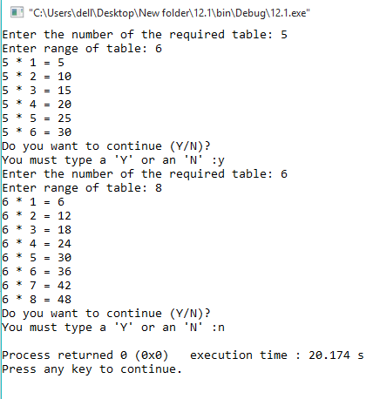

**Lab Task. 12.2) Write a program to find a factorial using while loop.**

#include <iostream>

using namespace std;

int main()

{

int number, i = 1, factorial = 1;

cout << "Enter a positive integer: ";

cin >> number;

while ( i <= number) {

factorial *= i; //factorial = factorial * i;

++i;

}

cout<<"Factorial of "<< number <<" = "<< factorial;

return 0;

}

